Practical - 7
Aim: - XSS using DVWA
Cross-Site Scripting (XSS): -
- Cross-site scripting (XSS) is a type of computer security vulnerability typically found in Web applications.
- XSS enables attackers to inject client-side script into Web pages viewed by other users.
- A cross-site scripting vulnerability may be used by attackers to bypass access controls such as the same origin policy.
- In Addition, the attacker can send input (e.g., username, password, session ID, etc) which can be later captured by an external script.
- The victim's browser has no way to know that the script should not be trusted, and will execute the script. Because it thinks the script came from a trusted source, the malicious script can access any cookies, session tokens, or other sensitive information retained by the browser and used with that site.
Process of XSS using DVWA: -
- XSS Stored Menu
Select "XSS Stored" from the left navigation menu.
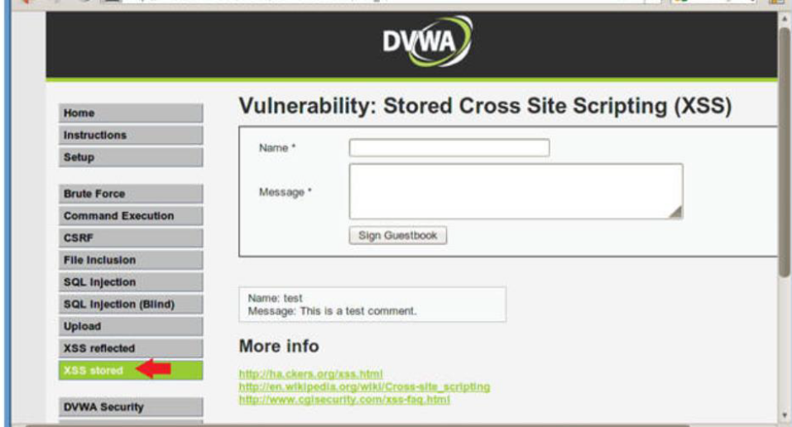
- Basic XSS Test
1. Name: Test 1
2. Message: <script>alert("hello")</script>
3. Click Sign Guestbook

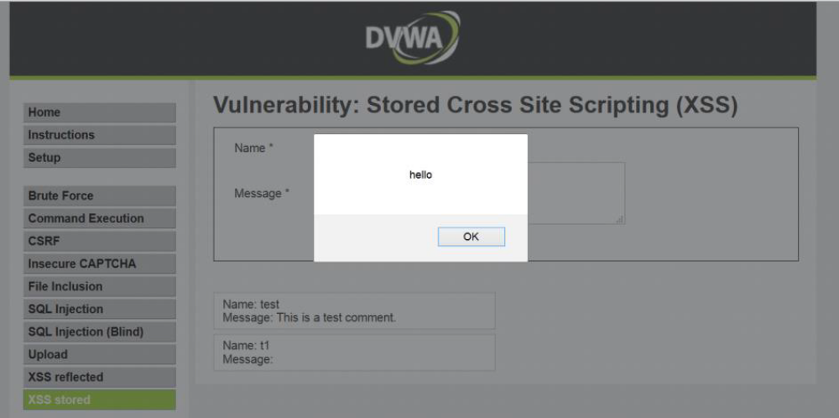
- Reset Database
1. Select "Setup" from the left menu navigation.
2. Click on the Create / Reset Database Button.

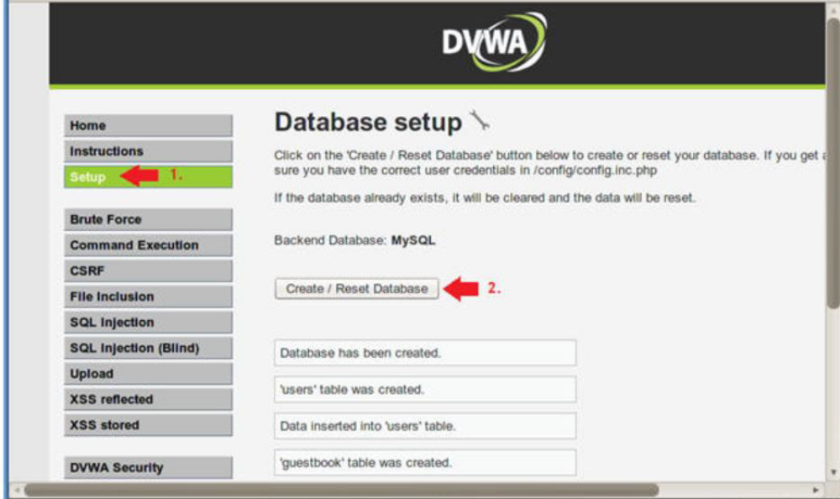

- XSS Stored Menu
1. Select "XSS Stored" from the left navigation menu.

- XSS Test 2
1. Name: Test 2
2. Message: <iframe src="http://wikipedia.org"></iframe>
3. Click Sign Guestbook

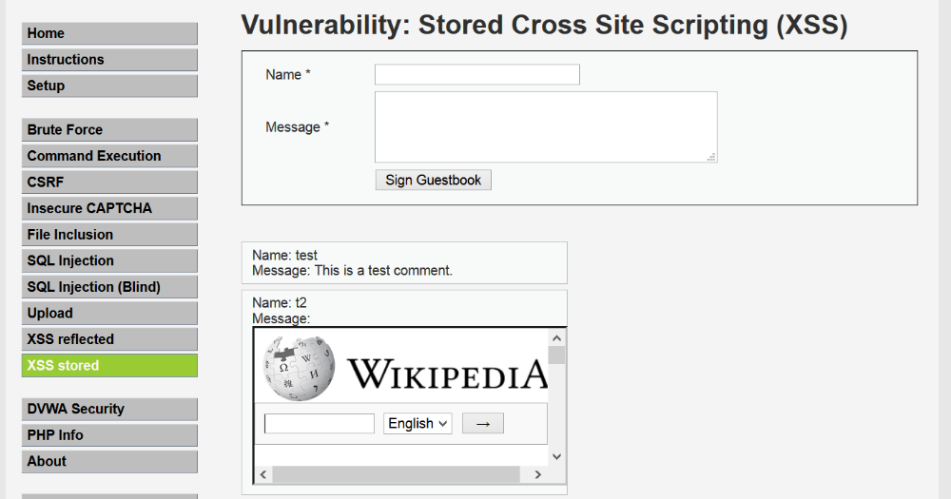
- XSS Stored COOKIE Exploit Test
Reset Database
1. Select "Setup" from the left menu navigation.
2. Click on the Create / Reset Database Button.
- XSS Test 3
1. Name: Test 3
2. Message: <script>alert(document.cookie)</script>
3. Click Sign Guestbook

